Datsun Roadster Project

Sometime in the early nineties, my dad brought home a 1968 Datsun Roadster and parked it in our backyard. There it sat for 30 years until he and I dug it out during my sophomore year of high school with plans of a full restoration. My goal at the time was to drive my girlfriend to senior prom in it. While that did not happen (not even close), it has turned out to be the most rewarding project I have worked on with all sorts of fun challenges along the way. While there was a massive amount of body filler and rewiring the entire car, one of the biggest parts of the restoration (for me) was creating a custom dashboard from scratch.
The 1968 Roadster came with a vinyl covered foam padded dashboard. It was ugly and did not at all match the style of the rest of the car. In fact, throughout the span of the Roadster’s production, the design never drastically changed – besides the ugly interior they put in for the 1968 model year. We decided that rather than restoring the ugly molded padded dash that was in there, we favored the look of the flat dash that had been in the earlier cars.
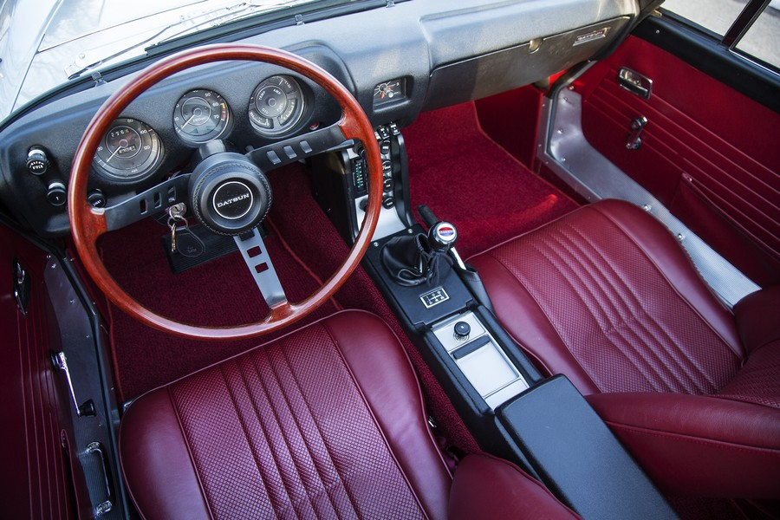
1968 Datsun Roadster Dashboard
(source: https://www.sportscarmarket.com/profile/1968-datsun-1600-roadster)

I did a lot of research on flat dash conversions for our car and found that it is a very involved process. It requires creating new brackets, lengthening wires, and cutting and welding of the dash, among others. All of this comes after forking out hundreds of dollars for a used, rusted out flat dash from a parts car. We therefore decided not to do a flat dash swap and opted to spend several times as much time and money developing our own lookalike kit. That way anyone in the Datsun community could easily swap our kit into their late model cars.
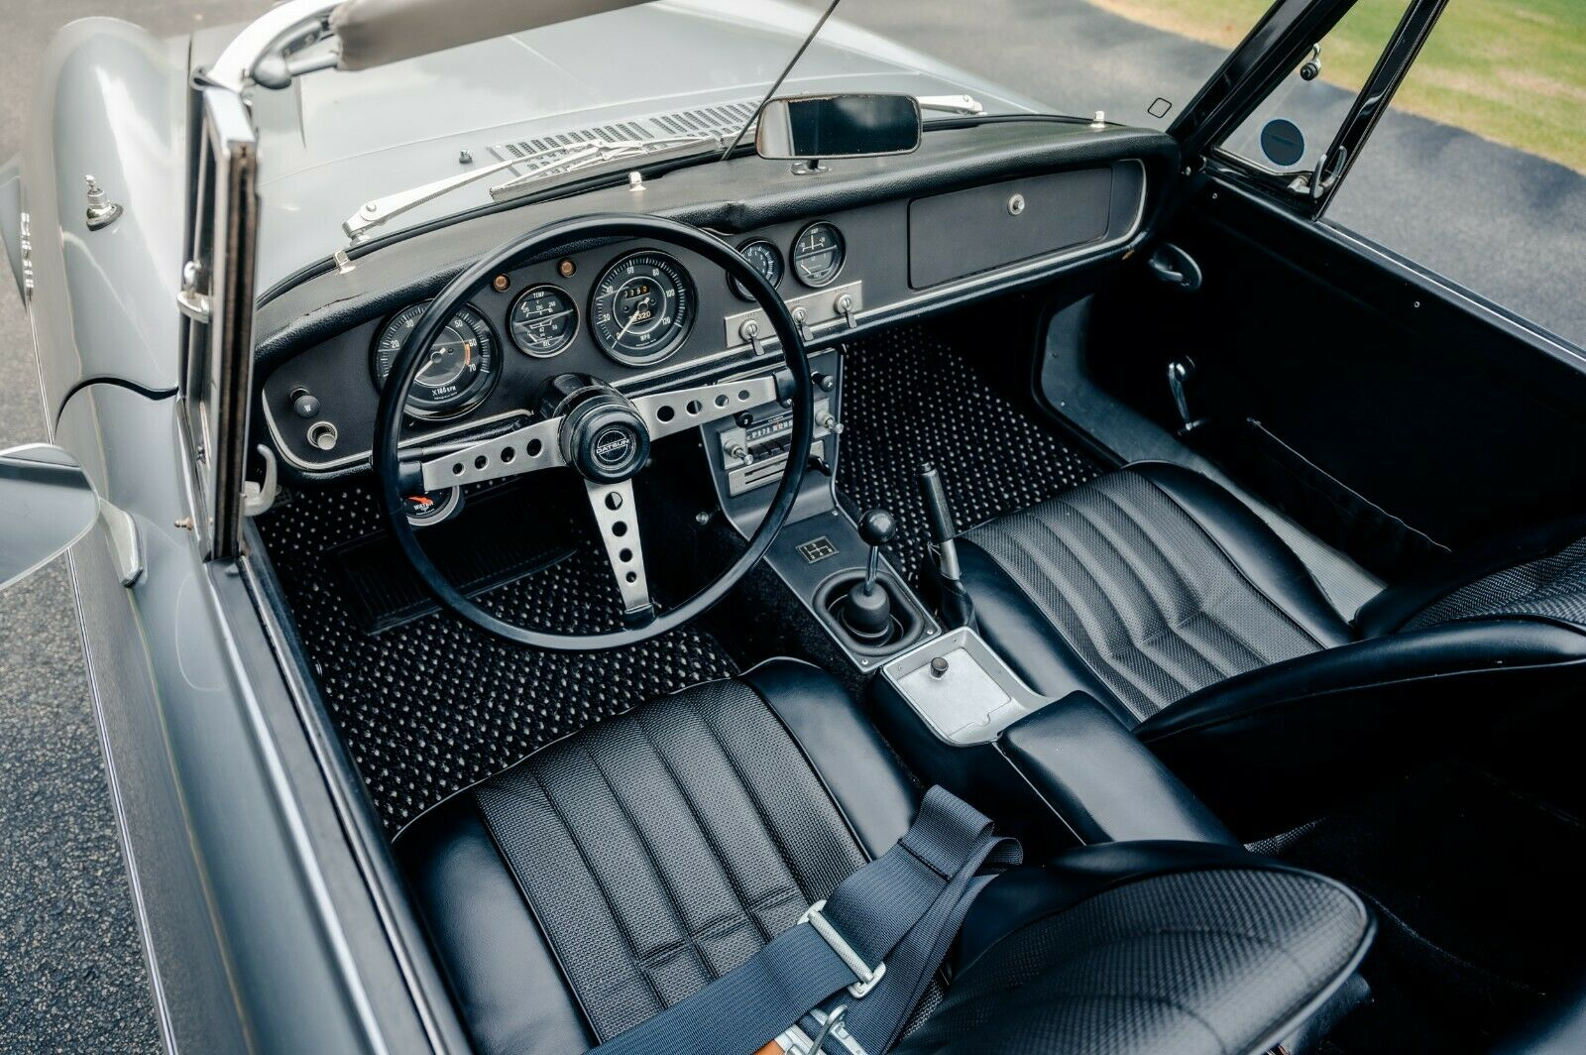
1967 Datsun Roadster Dashboard
(Source: https://www.ebay.com/motors/blog/a-datsun-1600-fairlady-imported-by-a-us-soldier-in-1967/)
We started by actually buying the roached and rotting dash out of a 1966 Roadster complete with the gauges appropriate for that year, along with a 3D scanner to digitize it. We decided on a budget Revopoint Pop 2 3D scanner, and used Fusion 360 to reverse engineer the original flat dash. This was the first time I’d ever had to reverse engineer anything, and it was made especially challenging due to it being an organic shape with compound curved features. After lots of trial and error, I was very happy with the result.
I never would have taken on this project without a plan to build it once the design was done. So, this project coincided with me starting my first semester of college and gaining access to a large CNC router. I still had no idea how to use it though. I initially practiced with CAM software by making little trinkets like a checkers board and decorative wood boxes. After many trial runs figuring out feeds and speeds, I crossed my fingers and sent the G-code to the machine.
(insert pictures (2).mp4 here)
Everything ran perfectly smoothly the first time, albeit I could have cut the machining time in half, and that still would be conservative for just cutting foam. The real issue came when we then prepared the mold to pull a fiberglass part on. The mold release began to dissolve the foam. The next obvious solution was to machine a more permanent mold out of MDF that could be used for several parts. That was much the same as the foam mold, and in the end I was left with a very nice looking part.
While the dash still needs some finishing touches, it is very nearly done and has been one of my favorite projects to date. It was rewarding to mount it in the car and be one step closer to driving it, albeit three years late to make my high school senior prom.
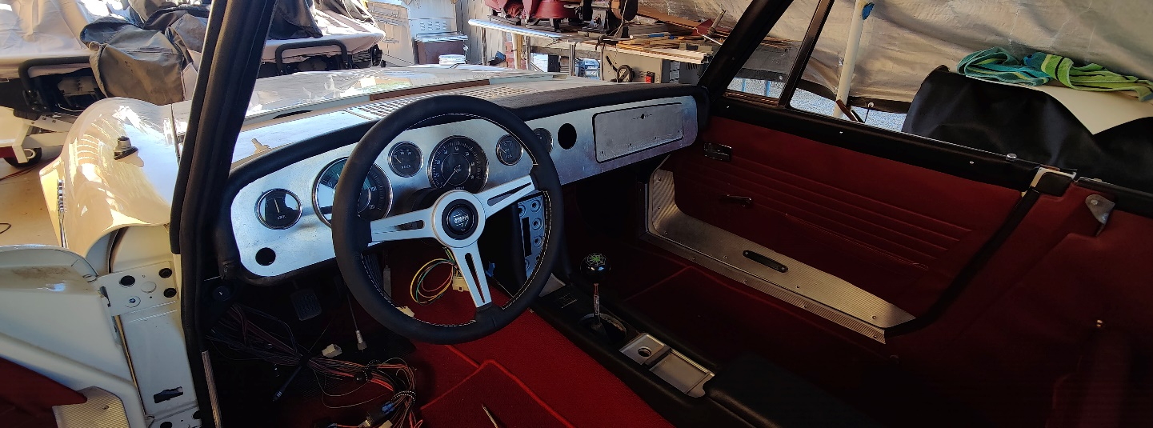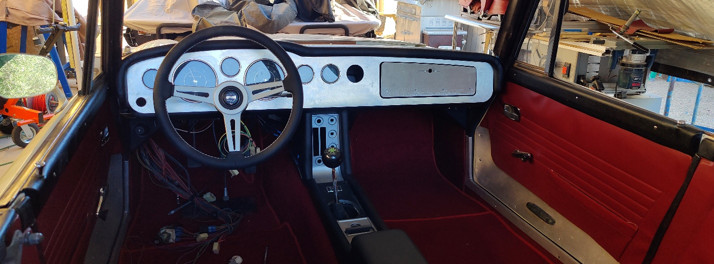
(Nearly) Finished Dashboard

